Bamazon app functionality:

* When the Bamazon CLI app is started, a list of all the products available in the Bamazon database is displayed (see screenshot below)
  + List display uses Console Table NPM package

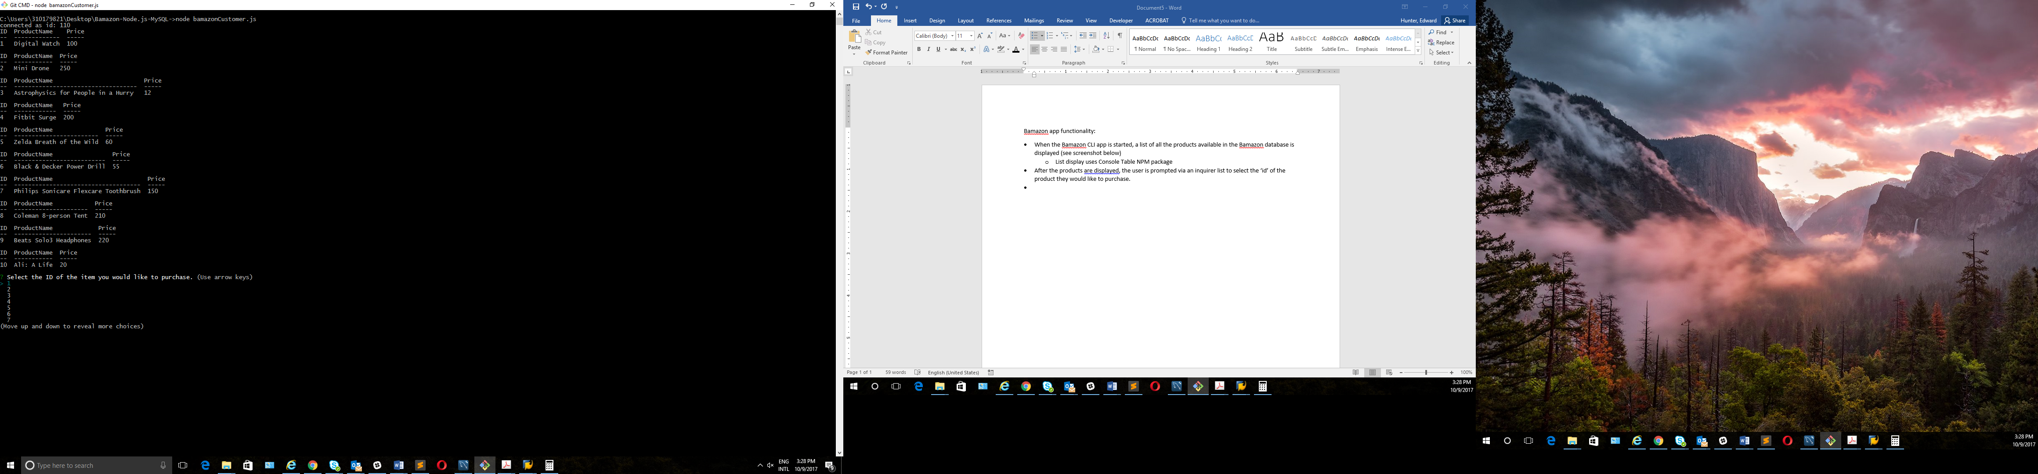

* After the products are displayed, the user is prompted via an inquirer list to select the ‘id’ of the product they would like to purchase.



* Once an id is selected, the user is prompted to enter the quantity of the item they would like to purchase

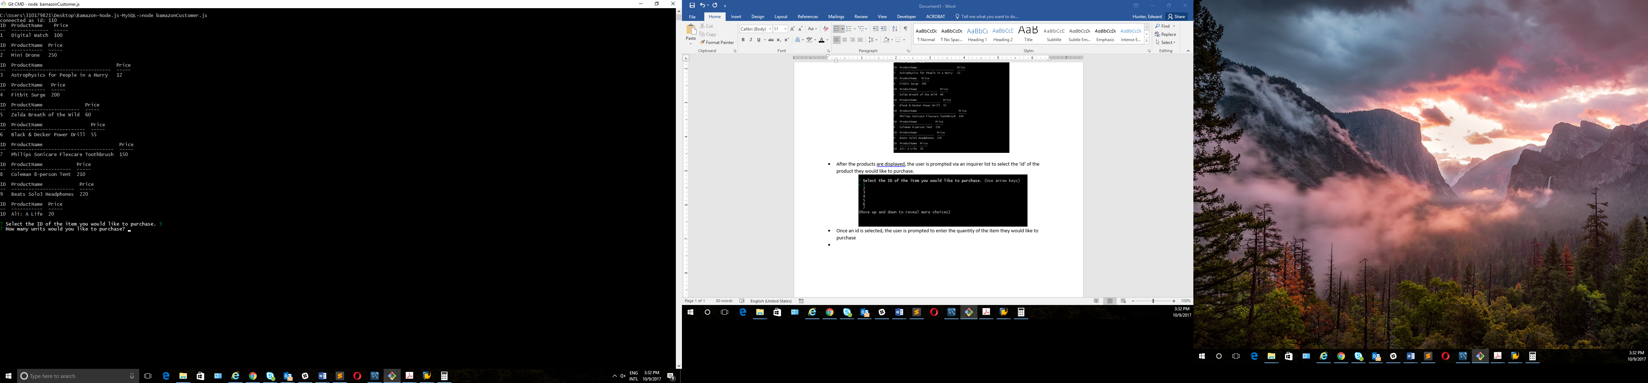

* The user then enters their purchase quantity. If there is sufficient quantity in stock to fulfill the order, the message “Item(s) purchased successfully. Total cost: $’ ‘” is printed, with the total cost being calculated in the background and displayed in the message.

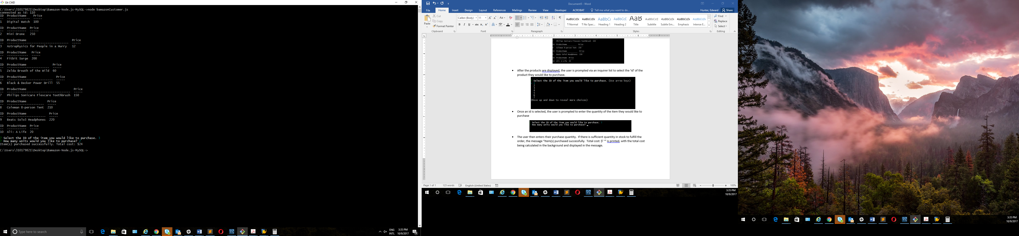

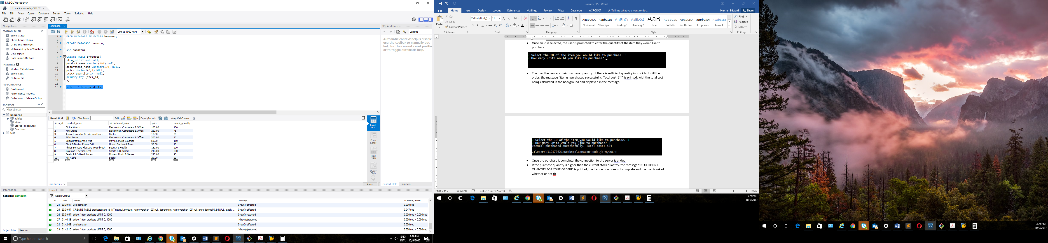

**(Before purchasing 2 units of “Astrophysics for People in a Hurry”)**

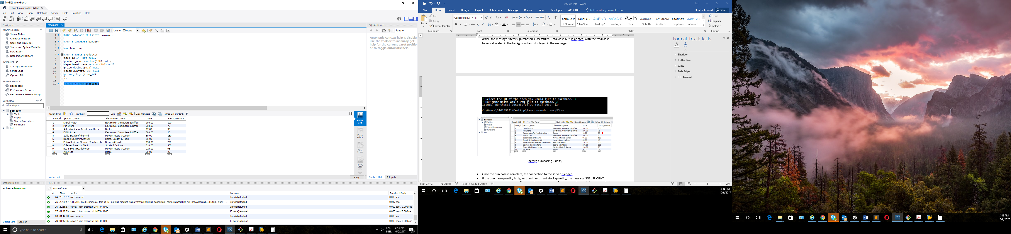

**(After purchasing 2 units of “Astrophysics for People in a Hurry”)**

* Once the purchase is complete and the database is updated, the connection to the server is ended.
* If the purchase quantity is higher than the current stock quantity, the message “INSUFFICIENT QUANTITY FOR YOUR ORDER!” is printed, the transaction does not complete, and the user is asked whether or not they would like to make another purchase:

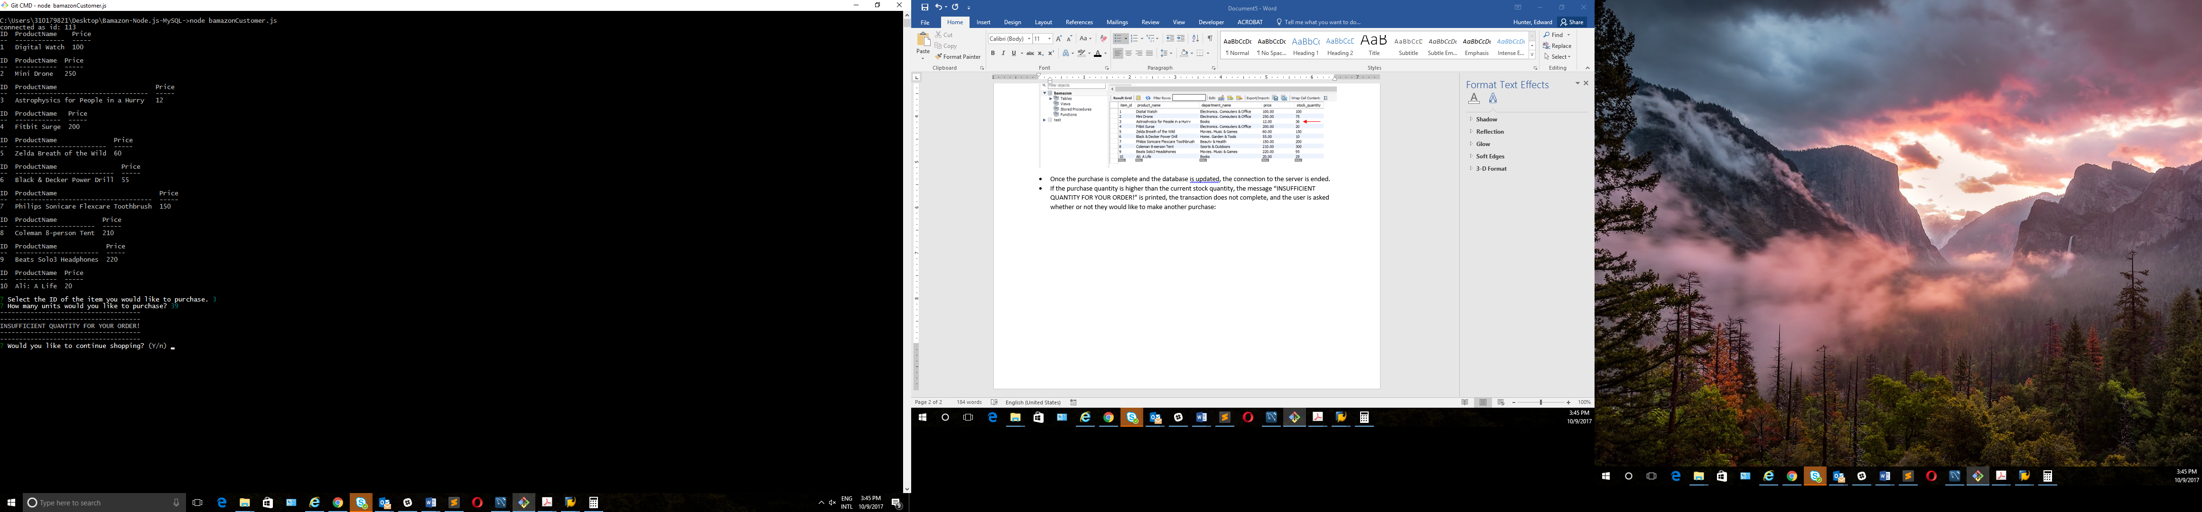

* If the user selects “no”, the connection to the server is ended. If the user selects “yes”, the app restarts, printing the product list again.

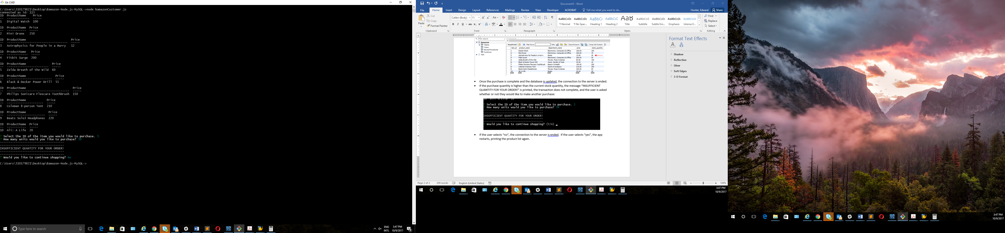

**(If no is selected)**

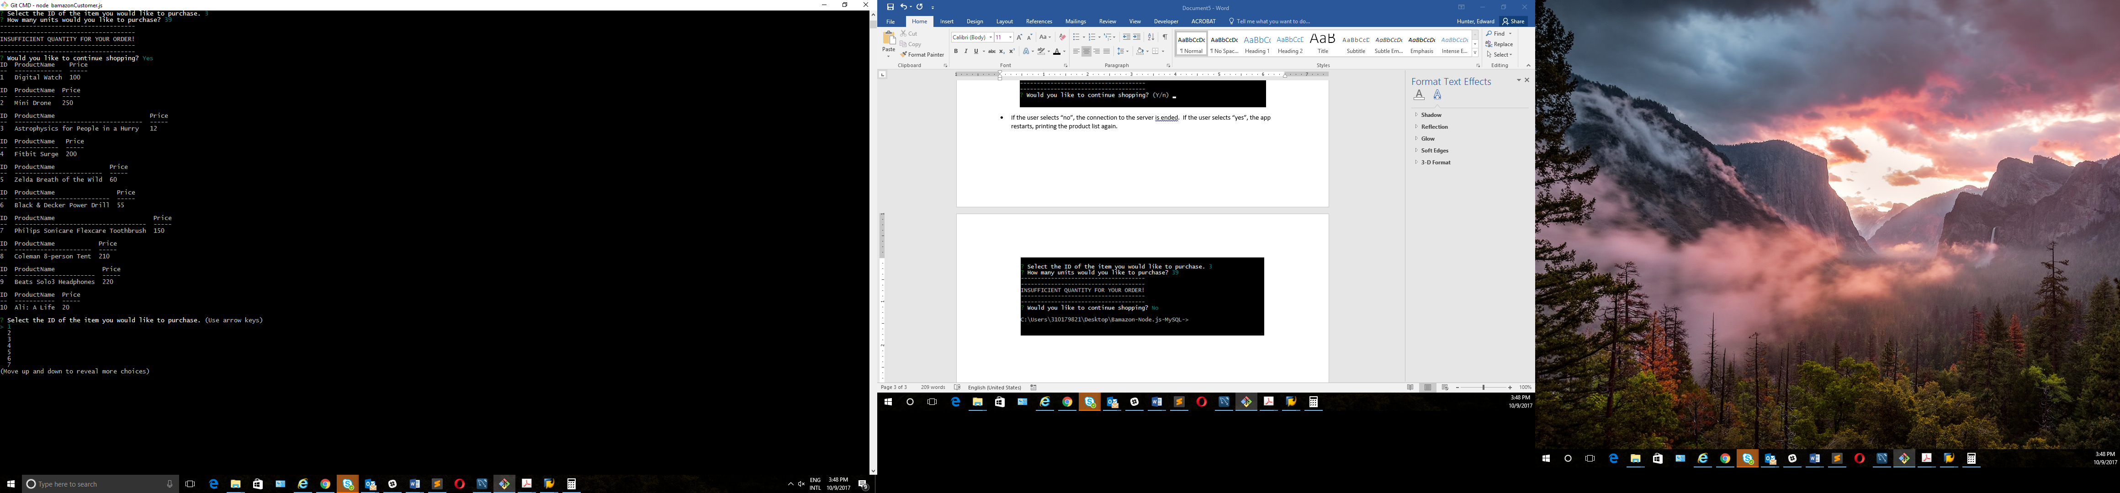

**(If yes is selected)**